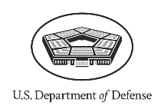

U.S. Department *of* Defense

**News Release**

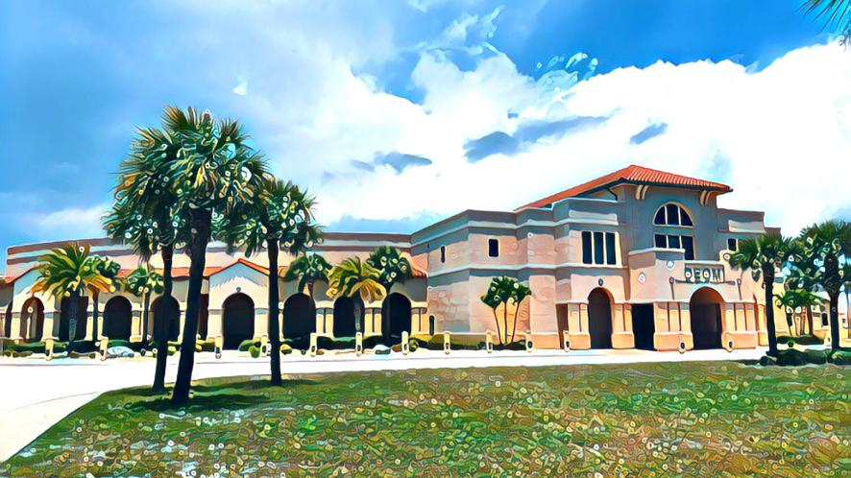

**DEOMI**

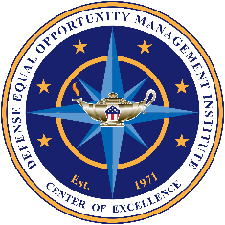

Defense Equal Opportunity Management Institute

***‘READINESS… Is Our Guiding Principle’***

IMMEDIATE RELEASE

**DEOMI Issues 2023 Pride Month Poster**

**June 1, 2023**

**Department of Defense 2023 Observance Poster for Pride Month.  The poster depicts Harvey Milk, a civil rights pioneer for LGBT rights.  His picture is set upon a rainbow colored background.

At the bottom of the poster is a photograph of the USNS Harvey Milk a naval oiler and replenishment ship.  The ships logo/seal is at the left side of the photograph  PATRICK SPACE FORCE BASE, Fla.—** In observance of Pride Month, the Defense Equal Opportunity Management Institute (DEOMI) proudly announces the availability of original artwork available for download from DEOMI’s public website, [www.defenseculture.mil](http://www.defenseculture.mil).

June is Pride Month. It is observed in June to commemorate the riots that occurred in June 1969 at the Stonewall Inn in Manhattan, New York and became the catalyst for the gay rights movement in the United States and around the world. Today, Pride Month recognizes the achievements of this movement and continuing efforts to ensure equal rights for those whose sexual orientation or gender identity falls outside the mainstream. This year’s Pride Month theme is, ***“Equality Without Exception.”***

The 2023 Pride Month Observance poster highlights gay rights activist Harvey Milk, and one of the U.S. Navy’s newest John Lewis-class fleet oilers named in his honor.

In 1977, Harvey Milk was elected to serve on the San Francisco Board of Supervisors, making him the first openly gay man elected to public office in California. In this position, he fought against discrimination based on sexual orientation. Milk was shot and killed the following year.

Harvey Milk was a Lieutenant in the U.S. Navy during the Korean War, where he served as a diving officer aboard the submarine rescue ship USS Kittiwake. In 1955, he was forced out of the Navy because of his homosexuality.

In July 2016, the 75th U.S. Secretary of the Navy Ray Mabus commissioned the USNS Harvey Milk. The oiler officially launched during a christening ceremony held on Nov. 6, 2021. It is the second of six ships in the Navy’s fleet oiler program to be commissioned and named in honor of civil and human rights leaders. During the christening ceremony, 78th U.S. Secretary of the Navy Carlos Del Toro expressed hope that the ship naming helps right past wrongs and he reaffirmed the Navy’s commitment to providing a welcoming and inclusive environment for all qualified Americans who want to serve.

All DEOMI poster files are in the public domain. All DEOMI special observance poster images are high resolution and may be used to print posters up to 30 x 40 inches. DEOMI does not print posters or mail them out to requestors. Users, however, must credit the Defense Equal Opportunity Management Institute when using them.**1** In addition, please check out our website for a wide variety of new products we have prepared to help our Equal Opportunity/Equal Employment Opportunity and Command Climate Professionals in the Field, Fleet, Wing, and Agency. DEOMI develops and delivers innovative education, training, research, and collaborative solutions to optimize total force readiness. For more details, contact DEOMI Public Affairs Office: 366 Tuskegee Airmen Dr., Patrick SFB, FL 32925, Email: deomipa@us.af.mil.